Yale Center for Industrial Ecology Lunchtime Talk
THE IMPACTS OF MATERIAL SUPPLY AVAILABILITY ON A TRANSITIONING ELECTRIC POWER SECTOR
Presented by Yang Qiu
Hybrid Event: Friday, April 19/ Noon to 1 pm
Lunch available 380 Edwards Street/ Zoom link https://yale.zoom.us/j/97726270559
Dr. Qiu is with the Joint Global Change Research Institute, Pacific Northwest National Laboratory which seeks to advance fundamental understanding of human and Earth systems to provide decision-relevant information for management of emerging global risks and opportunities
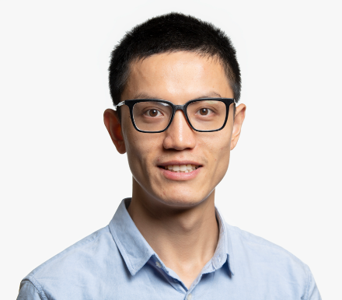
The future energy system is poised for a transition towards a greater integration of low-carbon technologies, which could substantially increase material demands–including demand for critical materials such as copper, lithium, and rare earth elements, etc. However, material demands may outpace the rate at which these materials can be supplied, suggesting important implications for the scale and pace of energy technology deployment. Understanding how future material supply availability might affect the evolution of the energy system is critical for decision-makers as they plan on making long-lived investments now to meet future energy demands. In this talk, I aim to introduce a new capability we have developed in the Global Change Analysis Model (GCAM)–a state-of-the-art and open-source integrated assessment model–to explicitly track demands and supply constraints of 12 critical materials in the global power sector. I will discuss the impacts of material supply availability on the global power sector and the potentials of key strategies (e.g., increased material supply, reduced material intensity) in mitigating these impacts based on our model results.
Bio: Dr. Qiu’s research interests focus on global and regional energy system transitions, the interactions of energy system transition with the demand and supply of critical minerals, and carbon management technologies. He received his Ph.D. in Environmental Science & Management at UC, Santa Barbara, his M.S. in Environmental Science and B.S. in Forestry from SUNY College of Environmental Science and Forestry and Beijing Forestry University, respectively.

